**AI-Powered E-Learning Web Application**

__________________________________________

Final Year Project Report

by

|  |  |
| --- | --- |
| **Rubab Munir** | **BCSF21M037** |
| **Amna** | **BCSF21M046** |
| **Sarfraz Khan** | **BCSF21M038** |
| **Sameer Jugno** | **BCSF21M048** |

Project Advisor:

**Dr. Shuja-ur-Rehman**

**Faculty of Computing & Information Technology,**

**University of the Punjab, Lahore, Pakistan.**

**(2025)**

**GitRepo URL:**

**User Guide for AI-e-Learning Platform**

1. **Introduction**

Welcome to the AI-e-Learning Platform! This guide will walk you through how to navigate the platform, interact with its features, and understand the output you will see during your use of the platform.

1. **Starting the Prototype**

### 2.1 Accessing the Platform:

* Open your preferred browser (e.g., Chrome, Firefox, Edge).
* Navigate to the home page of the **AI-e-Learning Platform**. This is where the main content will be displayed.

**2.2 Features on the Home Page:**

Once you are on the home page, you will see the following elements:

1. **Navigation Bar**:

* **Home**: Takes you back to the main page.
* **Tutorial**: Opens the tutorial section where you can explore programming language tutorials.
* **Exercises**: Leads you to the exercises section where you can start quizzes and challenges.
* **Log In**: Allows users to log into their accounts.
* **Sign Up**: Takes you to the registration page for new users.
* **Start Free**: Offers a free start option to engage with courses

1. **Hero Section**:

* A welcome message and a "Start Free" button appear, encouraging you to get started.

1. **Video Background**:

* A muted video plays in the background to provide a visually engaging introduction.

1. **Features Section**:

* Displays the key features of the platform, like **Course Development**, **Content Conversion**, and **SCORM** compliance.

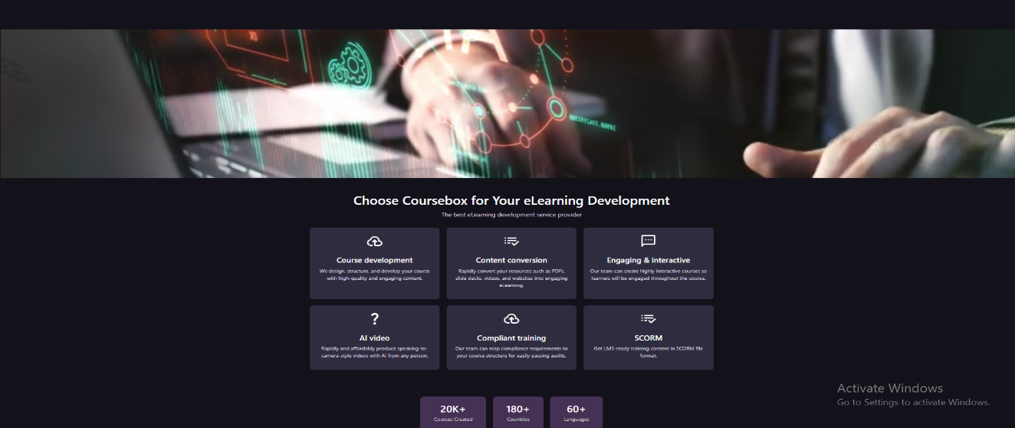

1. **Interaction Sequence:**

**3.1 Using the Navbar:**

* You can navigate between the sections of the platform using the navigation bar at the top of the page.
  + **Home**: You will return to the landing page.
  + **Tutorial**: Clicking on this will open a page listing various programming languages like C++, Python, HTML, etc.

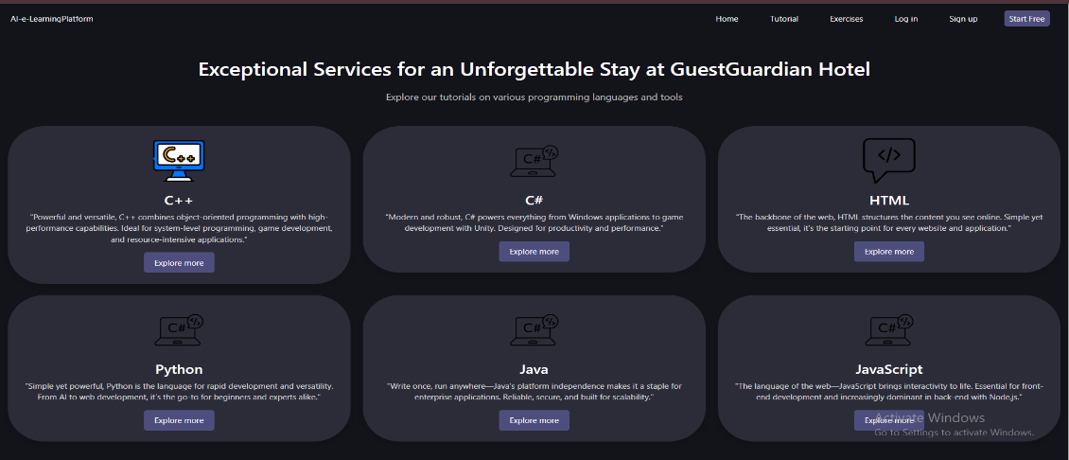

* **Action**: Click the "Explore more" button next to any language to view detailed tutorials for that language.
* **Exercises**: This page lets you start quizzes and exercises to test your skills in various programming languages.

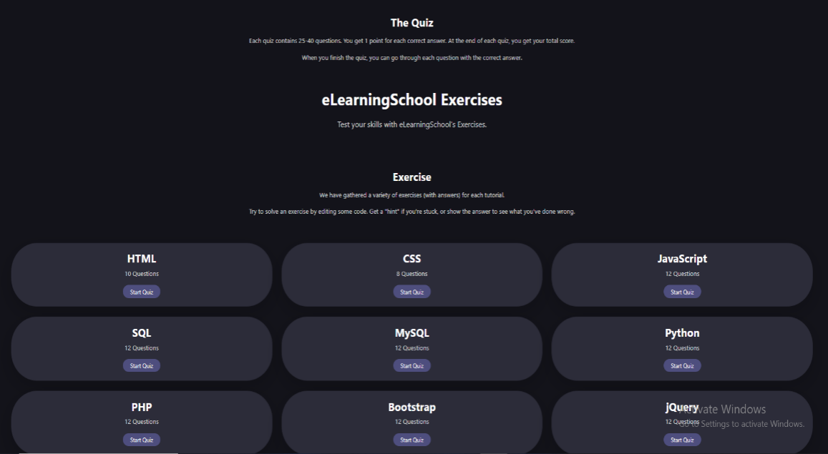

* + **Action**: Click on any of the available courses to start a quiz or exercise.
* **Log In**: If you have an account, you can log in with your credentials.

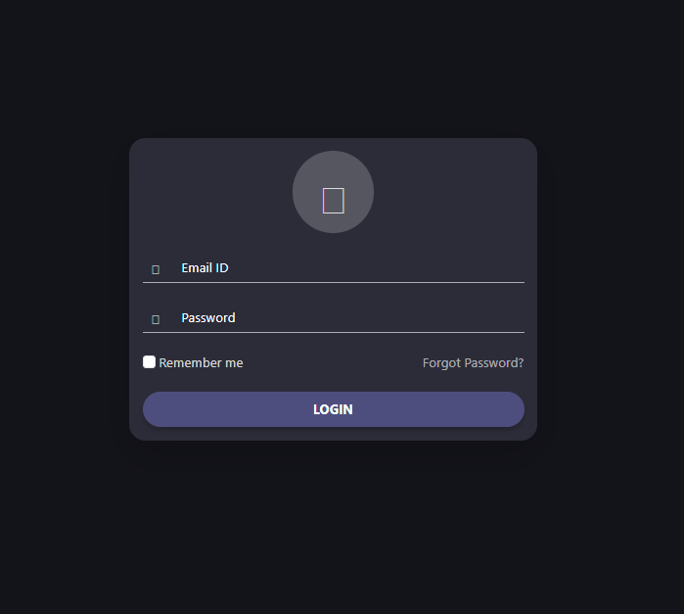

* **Sign Up**: New users can create an account here.

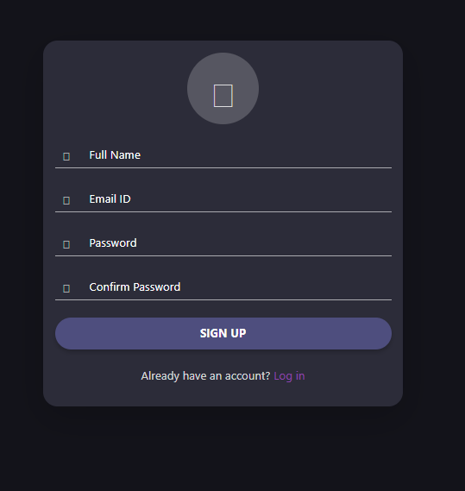

**3.2 Chatbot Icon:**

The **Chatbot Icon** is located at the bottom-left corner of the screen.

**Action**: Clicking this icon opens the chatbot page where you can interact with a virtual assistant for help.

**3.3 Exercises Section:**

In the **Exercises** section, you will see **Course Cards** for different languages and tutorials.

Each card shows the **number of questions** available for the course.

**Action**: Click "Start Quiz" or "Start Exercise" to begin.

As you complete quizzes, you will see questions with multiple-choice options. After selecting an answer, you can move to the next question.

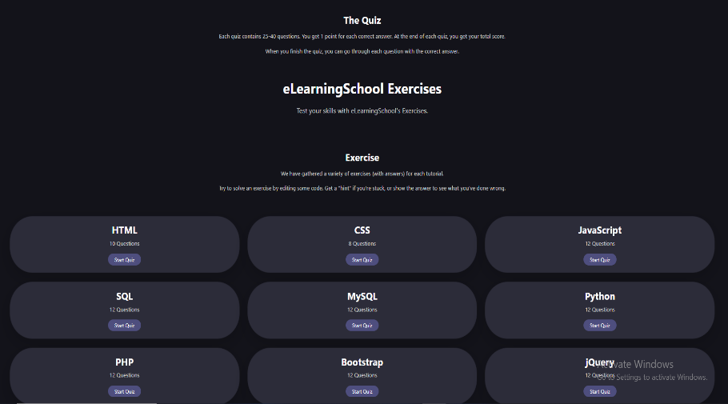

1. **Output and Feedback to Users**
   1. **Quiz Results:**

After completing a quiz, you will receive feedback in the form of:

**Your Total Score**: Displays the number of correct answers out of the total questions.

**Correct Answers Review**: You can review the correct answers for each question once the quiz is finished.

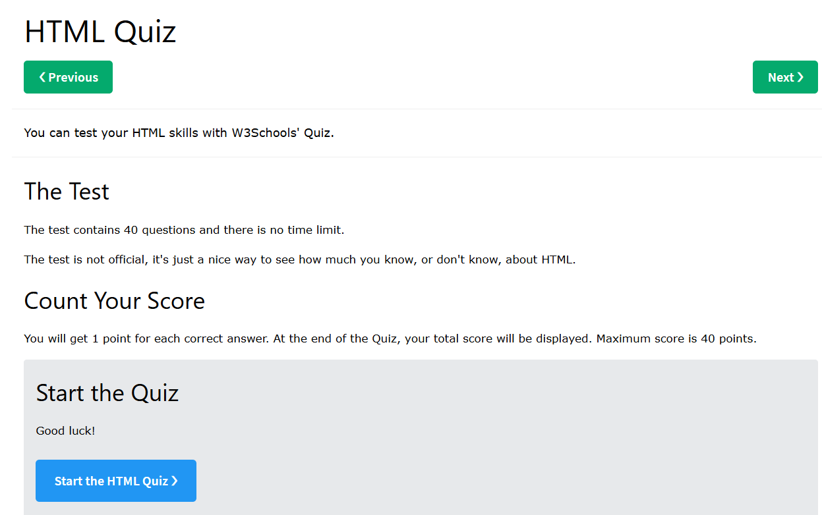

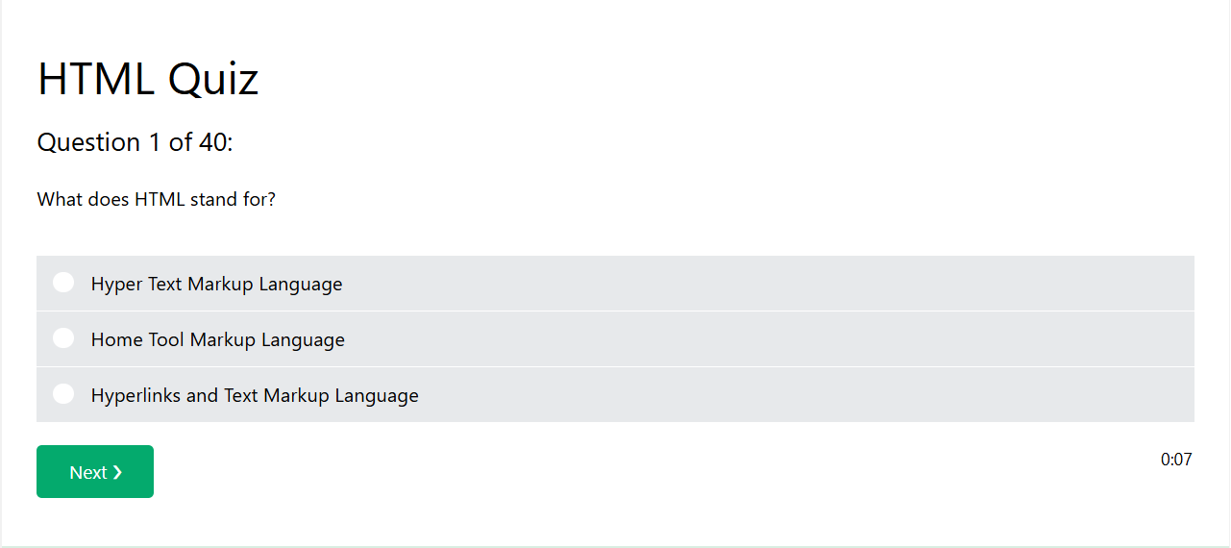

* 1. **Chatbot:**

The **Chatbot** will provide responses based on your input. The chatbot will be a helpful assistant for guiding you through the platform, answering questions, and providing further support.

* 1. **Profile and Authentication:**

When you log in, your profile is recognized, and you can save progress in quizzes and exercises.

1. **Troubleshooting and FAQs**

**Page Not Loading**: If you encounter a blank page or a delay in loading, try refreshing the browser or checking your internet connection.

**Quiz Not Advancing**: If the quiz isn't advancing, make sure you've selected an answer before clicking "Next."

**5.2 FAQ:**

**How do I start using the platform?**

Simply visit the home page, explore the tutorials or exercises, or sign up to get started.

**What happens when I finish a quiz?**

After completing a quiz, you'll see your score and have the option to review your answers.

**How do I contact support?**

Use the chatbot for quick help or visit the FAQ section.